

Lab Mid
  - OOP
Instructor: Mr. Mohsin Ahmed

Student Name: |  | Muhammad Abdullah
Registration No: |  | FA24-BSE-042
Department: |  | Software Engineering
Submission Date: |  | 22th October 2022

  - COMSATS University Islamabad

Answer #1
Code:

package Lab_Mid;

abstract class Vehicle {
private String vehicleNumber;
private String ownerName;

public Vehicle(String vehicleNumber, String ownerName) {
this.vehicleNumber = vehicleNumber;
this.ownerName = ownerName;
}

public String getVehicleNumber() {
return vehicleNumber;
}

public String getOwnerName() {
return ownerName;
}

public abstract double calculateParkingFee(int hours);
}

class Car extends Vehicle {
private static final double FIRST_HOUR_FEE = 50;
private static final double PER_HOUR_RATE = 30;

public Car(String vehicleNumber, String ownerName) {
super(vehicleNumber, ownerName);
}

@Override
public double calculateParkingFee(int hours) {
if (hours <= 1) return FIRST_HOUR_FEE;
return FIRST_HOUR_FEE + (hours - 1) * PER_HOUR_RATE;
}
}

class Bike extends Vehicle {
private static final double FIRST_HOUR_FEE = 20;
private static final double PER_HOUR_RATE = 10;

public Bike(String vehicleNumber, String ownerName) {
super(vehicleNumber, ownerName);
}

@Override
public double calculateParkingFee(int hours) {
if (hours <= 1) return FIRST_HOUR_FEE;
return FIRST_HOUR_FEE + (hours - 1) * PER_HOUR_RATE;
}
}

class Truck extends Vehicle {
private static final double FIRST_HOUR_FEE = 100;
private static final double PER_HOUR_RATE = 70;

public Truck(String vehicleNumber, String ownerName) {
super(vehicleNumber, ownerName);
}

@Override
public double calculateParkingFee(int hours) {
if (hours <= 1) return FIRST_HOUR_FEE;
return FIRST_HOUR_FEE + (hours - 1) * PER_HOUR_RATE;
}
}

class ParkingSlot {
private Vehicle vehicle;

public ParkingSlot(Vehicle vehicle) {
this.vehicle = vehicle;
}

public void showParkingDetails(int hours) {
System.out.println("Vehicle No: " + vehicle.getVehicleNumber());
System.out.println("Owner: " + vehicle.getOwnerName());
System.out.println("Total Fee: $" + vehicle.calculateParkingFee(hours));
System.out.println("---------------------------");
}
}

public class SmartParkingRunner {
public static void main(String[] args) {
ParkingSlot carSlot = new ParkingSlot(new Car("CAR-2025", "Abdullah"));
ParkingSlot bikeSlot = new ParkingSlot(new Bike("BIKE-909", "Ali"));
ParkingSlot truckSlot = new ParkingSlot(new Truck("TRUCK-777", "Zain"));

carSlot.showParkingDetails(3);
bikeSlot.showParkingDetails(2);
truckSlot.showParkingDetails(5);
}
}

Output:

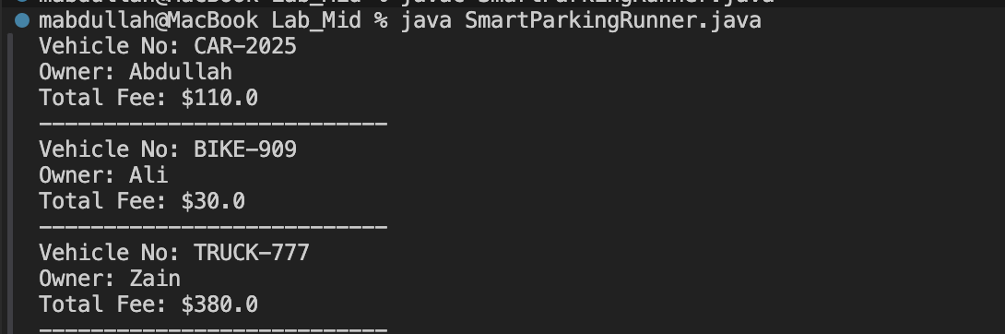

Summary:

Inheritance: Car, Bike, and Truck extend the abstract base class Vehicle. This means they share the common fields and methods of Vehicle.
Polymorphism: All subclasses provide their specific implementation for the abstract method calculateParkingFee(int hours), which is the core difference between the vehicle types.
Composition: ParkingSlot holds a single Vehicle reference. The ParkingSlot doesn't care which specific type of vehicle it holds; it relies on the generic Vehicle interface (Polymorphism) to call calculateParkingFee().
Abstraction: Vehicle is marked as an abstract class (<<abstract>>) with an abstract method, enforcing the calculateParkingFee contract for all derived classes.

Class Diagram:
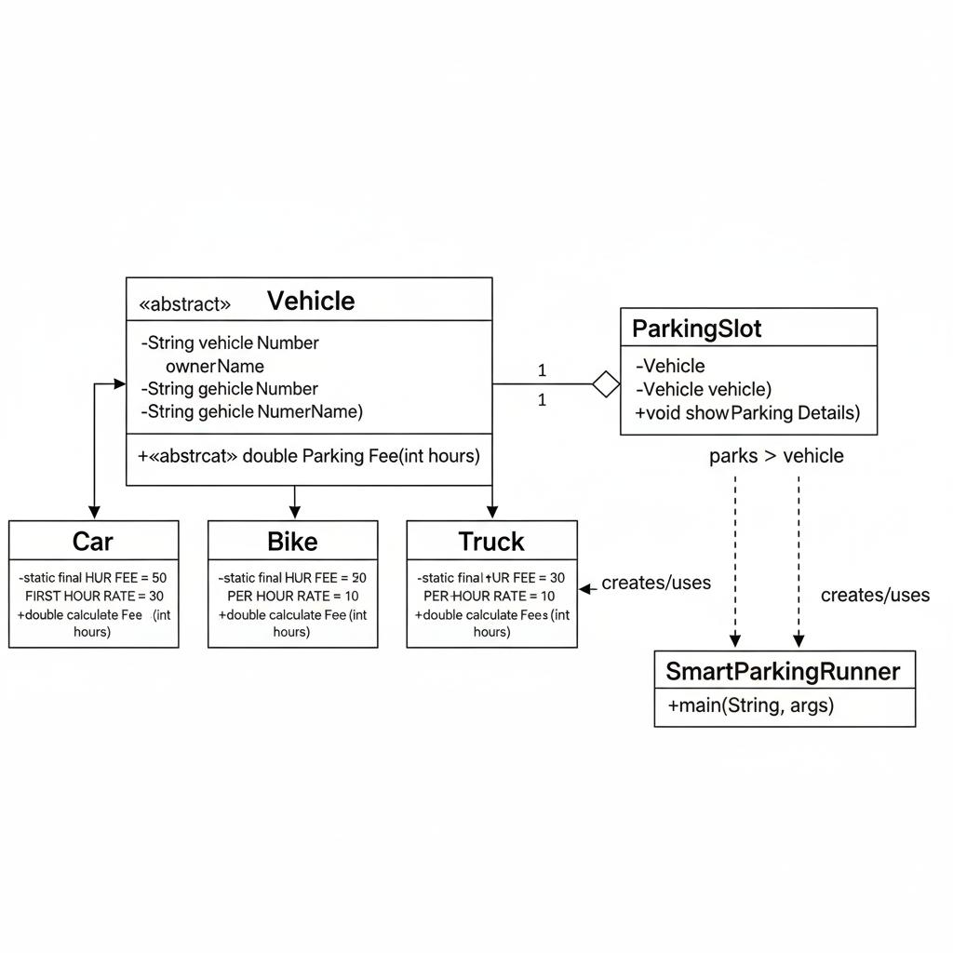

Answer #2
Code:
package Lab_Mid;

import java.util.*;

abstract class SmartDevice {
private String deviceId;
private String deviceName;
private boolean powerStatus;
private String networkName;

public SmartDevice(String deviceId, String deviceName) {
this.deviceId = deviceId;
this.deviceName = deviceName;
this.powerStatus = false;
}

public String getDeviceId() {
return deviceId;
}
public String getDeviceName() {
return deviceName;
}
public boolean getPowerStatus() {
return powerStatus;
}

public void connectToNetwork(String networkName) {
this.networkName = networkName;
System.out.println(deviceName + " connected to network: " + networkName);
}

public void turnOn() {
powerStatus = true;
System.out.println(deviceName + " is turned ON.");
}

public void turnOff() {
powerStatus = false;
System.out.println(deviceName + " is turned OFF.");
}

// Abstract method
public abstract void showStatus();
}

class SmartLight extends SmartDevice {
private int brightnessLevel;

public SmartLight(String id, String name, int brightnessLevel) {
super(id, name);
this.brightnessLevel = brightnessLevel;
}

@Override
public void turnOn() {
super.turnOn();
System.out.println("Light brightness set to " + brightnessLevel + "%");
}

@Override
public void showStatus() {
System.out.println(getDeviceName() + " | Light | Status: " + (getPowerStatus() ? "ON" : "OFF"));
}
}

class SmartFan extends SmartDevice {
private int speed;

public SmartFan(String id, String name, int speed) {
super(id, name);
this.speed = speed;
}

@Override
public void turnOn() {
super.turnOn();
System.out.println("Fan running at speed " + speed);
}

@Override
public void showStatus() {
System.out.println(getDeviceName() + " | Fan | Status: " + (getPowerStatus() ? "ON" : "OFF"));
}
}

class SmartThermostat extends SmartDevice {
private double temperature;

public SmartThermostat(String id, String name, double temperature) {
super(id, name);
this.temperature = temperature;
}

// Method overloading
public void setTemperature(double celsius) {
this.temperature = celsius;
System.out.println("Temperature set to " + celsius + "°C");
}

public void setTemperature(double value, boolean inFahrenheit) {
if (inFahrenheit) {
this.temperature = (value - 32) * 5 / 9;
System.out.println("Temperature set to " + temperature + "°C (converted from Fahrenheit)");
} else {
setTemperature(value);
}
}

@Override
public void turnOn() {
super.turnOn();
System.out.println("Thermostat set at " + temperature + "°C");
}

@Override
public void showStatus() {
System.out.println(getDeviceName() + " | Thermostat | Status: " + (getPowerStatus() ? "ON" : "OFF"));
}
}

// Composition
class SmartHomeController {
private List<SmartDevice> devices = new ArrayList<>();

public void addDevice(SmartDevice device) {
devices.add(device);
}

public void turnAllOn() {
for (SmartDevice d : devices) d.turnOn();
}

public void turnAllOff() {
for (SmartDevice d : devices) d.turnOff();
}

public void showAllStatus() {
for (SmartDevice d : devices) d.showStatus();
}
}

public class SmartHomeRunner {
public static void main(String[] args) {
SmartLight light = new SmartLight("L1", "Bedroom Light", 80);
SmartFan fan = new SmartFan("F1", "Ceiling Fan", 3);
SmartThermostat thermostat = new SmartThermostat("T1", "Room Thermostat", 22.5);

light.connectToNetwork("Home_WiFi");
fan.connectToNetwork("Home_WiFi");
thermostat.connectToNetwork("Home_WiFi");

SmartHomeController controller = new SmartHomeController();
controller.addDevice(light);
controller.addDevice(fan);
controller.addDevice(thermostat);

controller.turnAllOn();
thermostat.setTemperature(75, true); // Overloaded method
controller.showAllStatus();
controller.turnAllOff();
}
}

Output:

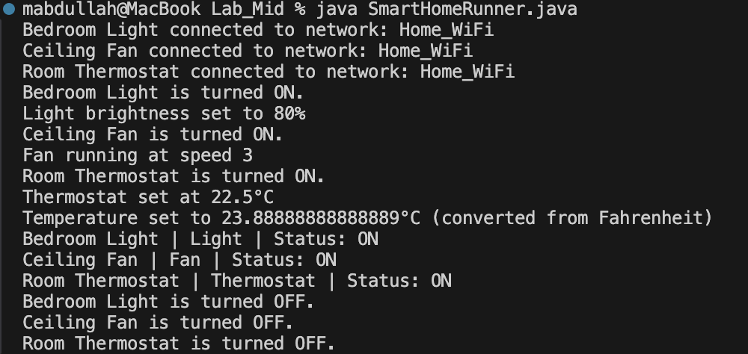

Class Diagram:
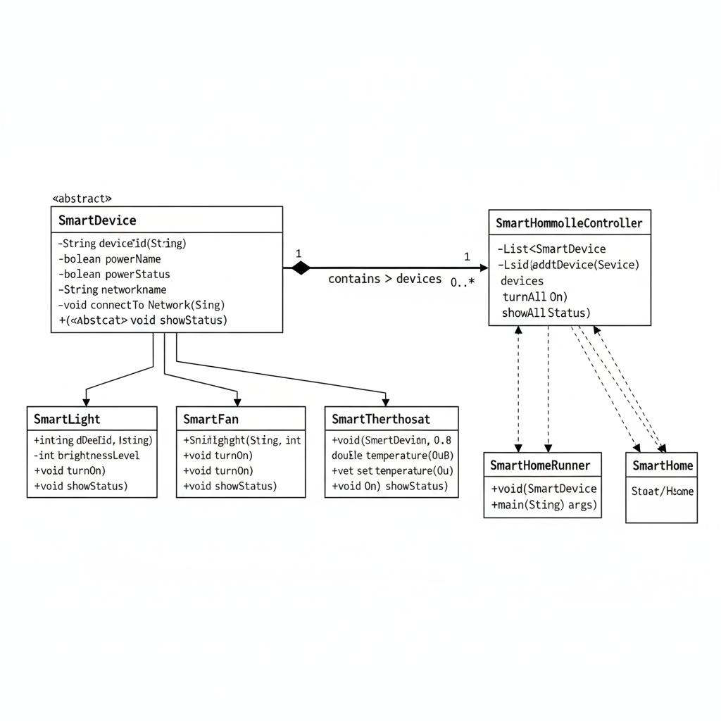
Summary:

Reusability is achieved via the abstract SmartDevice base class. It defines common behaviours like ( like turnOn, connectToNetwork, etc ) once, which are then inherited and reused by all subclasses ( SmartLight, SmartFan, etc ), preventing code deduplication.
Flexibility is provided by Polymorphism ( overriding & overloading ). SmartHomeController uses composition with the generic SmartDevice type.

